I’m in the process of making the visuals. I have this so far:

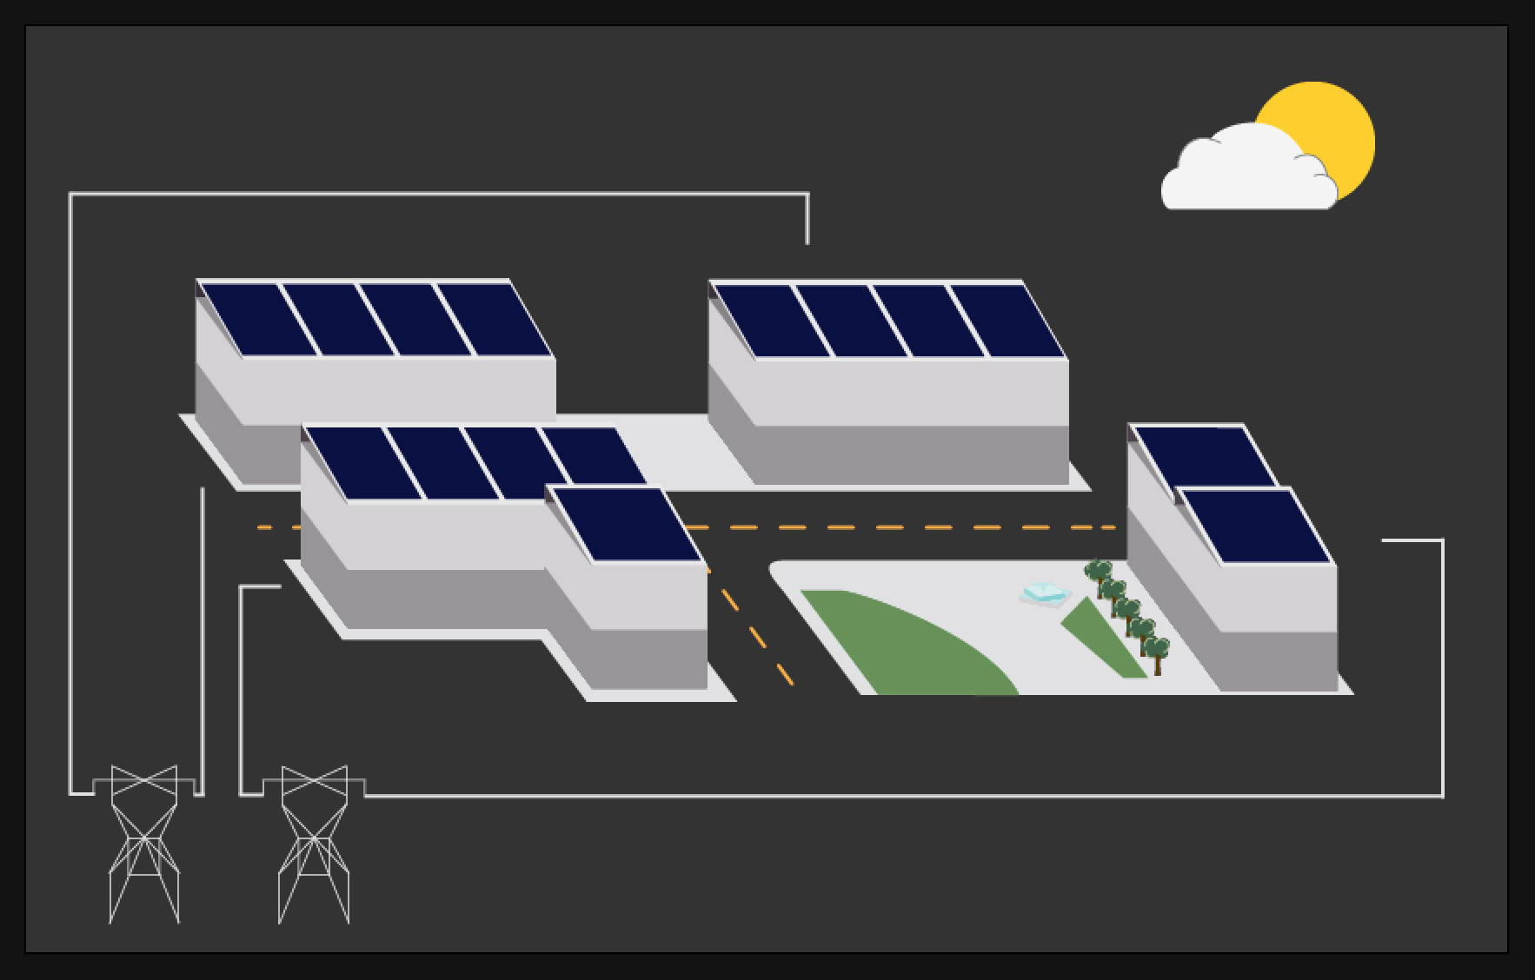

Can we implement animations similar to the ones seen in [this video](https://vimeo.com/92630207) (my inspiration). These animations would be active on page loading and depending on lag time, perhaps when data is updated. The animations I am most interested in is the way in which the object “pop” up from the “ground”. If I give you every layer of the buildings, would this be possible?

Design choices:

* Dark background: easier for visibility on digital devices AND saves energy for displays
* Sun changes based on PV production (sun, sun + clouds, clouds, rain), not necessarily on weather. This can show a discrepancy between what the PVs should be producing if it is sunny and therefore can lead into maintenance questions (maybe the panels need to be cleaned for 100% production capacity)
* Once you have this coded, I can give you break points and we can mess around with aesthetics for those breaks. I designed this for 1280 because I forget the dimensions of the TV (55in or 65 in).
* In the measurements, all of them are from the top left point of the svg.